Instructions
- This is an open-book exam, but all answers must be paraphrased and customized. Copying or plagiarism will result in suspension and a zero score for identical answers.
- You are permitted to use any tools to assist in answering the questions (ensure you mention the tools used), but all submissions must include well-commented responses.
- Each question carries equal weight unless stated otherwise.
Submission Instructions:
- Submit your SQL script as a .sql file and your python script as .html files
- Take screen shots or print the entire screen for SQL queries along with the output for each query
- Ensure your queries and codes are run successfully before submission.
- Partial marks will be awarded for partially correct answers.

Section A: SQL Case Study- Employee Management System
A company tracks its employees, their departments, salaries, and project assignments. The database consists of the following tables and data
- employees (employee_id, name, manager_id, department_id)
- departments (department_id, department_name)
- salaries (employee_id, salary)
- projects (project_id, project_name, department_id)
- employee_projects (employee_id, project_id)
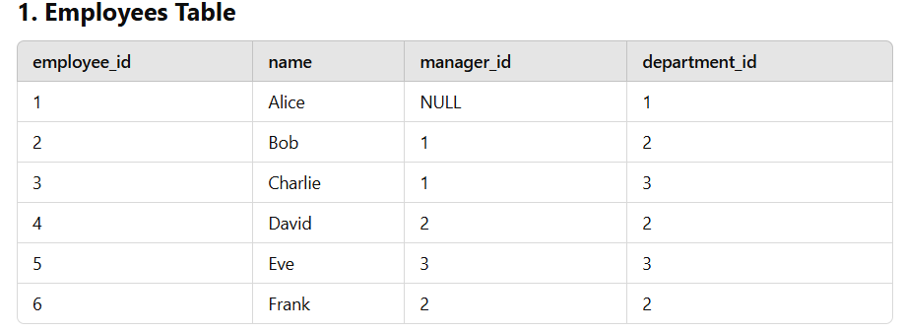
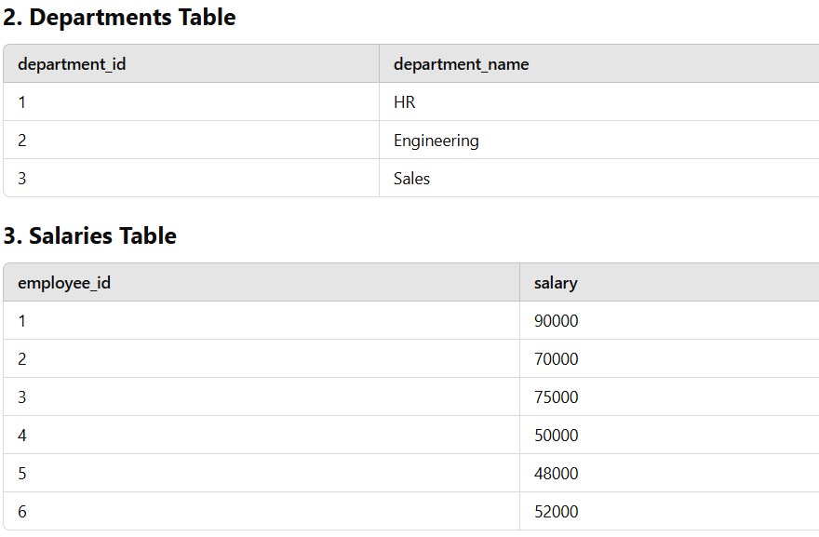

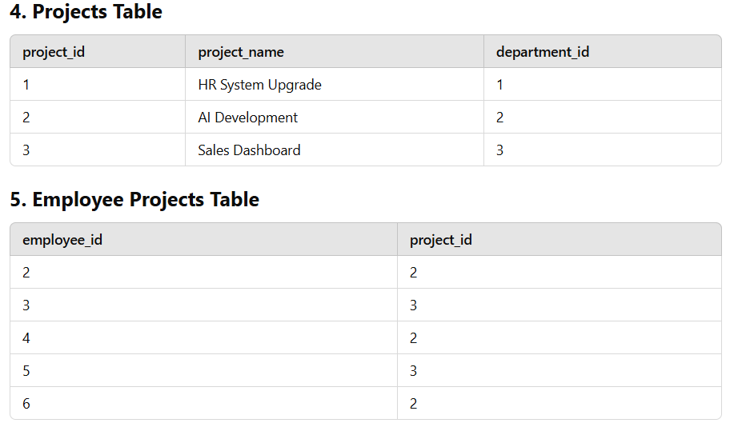
Instructions | All questions are mandatory to attend. | Marks
Q1. | Create all 5 tables in PostgreSQL and insert the above data | 15
Q2. | Write an SQL query to list all employees along with their manager's name. If an employee does not have a manager, display "No Manager". | 5
Q3. | Write an SQL query to find all employees who earn more than the average salary. | 5
Q4. | Write an SQL query to list all employees along with the projects they are assigned to. If an employee is not assigned to any project, show NULL in the project column. | 5
Q5. | Write an SQL query to find all departments where the average salary is greater than 60,000. | 5
Q6. | Write an SQL query to classify each employee into salary categories:  "High Salary" if salary > 80,000  "Medium Salary" if salary is between 50,000 and 80,000  "Low Salary" if salary is below 50,000 | 5

Section B: | For the provided dataset (train_Feb2025.csv’), use the file ‘data_description_Feb2025.txt’to understand each variable.  The variable ‘SalePrice’ represents the property sale price in dollars and is the target variable. Based on your understanding of the data, answer the following questions.  Submit your Jupyter notebook along with the output of your work in HTML format, including detailed explanations and insights
Instructions | All questions are mandatory to attend. | Marks
Q7. | Detailed EDA:  - Conduct a comprehensive Exploratory Data Analysis (EDA) on the dataset. This should include visualizing distributions, exploring relationships between variables, and summarizing key findings.  - Provide insights and interpretations that could be useful for building predictive models. You don’t need to build any predictive models, just perform a detailed analysis and EDA of the data. | 20
Q8. | Dummy Coding:  - Perform dummy coding on the categorical variables to incorporate them into a machine learning model. Explain the process and rationale. | 10
Q9. | Outlier Treatment:  - Detect and handle any outliers in the dataset. Describe the methods used for detection and the rationale behind your chosen treatment strategy. | 10
Q10. | Missing Values Treatment:  - Identify and treat missing values in the dataset. Explain the techniques used for imputation or other treatments and justify your approach. | 10
Q11. | Scaling or Normalization:  - Apply suitable scaling or normalization techniques to the dataset. Describe the methods used and explain why they are appropriate for this data. | 10

******End******

